DAILY VEHICLE INSPECTION REPORT
ORGANIZATION LOGO
 |  |  | VEHICLE CODE
INSPECTION DONE BY |  | KM  CURRENT:  NEXT SERVICE: | FUEL
DATE: | SIGNATURE |  | MAIN TANK | 1/4 | 1/2 | 3/4 | Full
NAME: |  |  | SECONDARY | 1/4 | 1/2 | 3/4 | Full
EQUIPMENT | VEHICLE - INTERIOR | 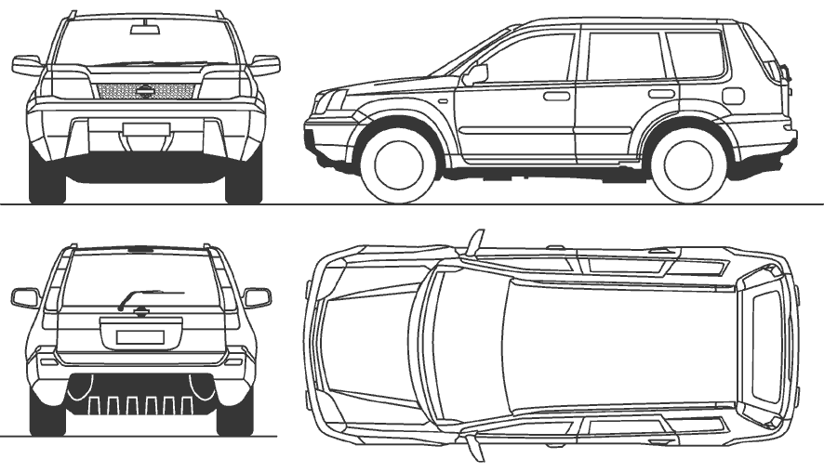
◻FIRST AID KIT  ◻FIRE EXTINGUISHER  ◻WARNING TRIANGLES  ◻SPARE WHEEL AND TYRE  ◻JACK AND HANDLE  ◻WHEEL SPANNER | ◻ REGISTRATION AND INSURANCE PAPERS  ◻ LOG BOOK  ◻ LIGHTS AND SIGNALS *functioning)  ◻ SEATS AND SEAT BELTS SECURITY  ◻ RADIO - CODAN  ◻ RADIO - VHF
ENGINE | VEHICLE - OUTSIDE
◻OIL LEVEL  ◻COOLANT LEVEL  ◻BRAKE FLUID LEVEL  ◻POWER STEERING FLUID  ◻WINDSHIELD WASHER FLUID  ◻FAN BELTS AND FAN  ◻BATTERY AND TERMINALS | ◻BODY PANEL CONDITION  ◻INSURANCE STICKER  ◻WINDSHIELD AND WINDOWS  ◻WINSHIELD WIPER BLADES  ◻SIDE MIRRORS  ◻TYRE CONDITION AND PRESSURE  ◻WHEEL NUT TIGHTNESS
DAMAGES AND OBSERVATIONS

